Jennifer:

- Finalize website content

1. Works

2. Papers and books on interaction

3. Appreciation of the United States

4. Preview of the exhibition- Collect Website Content

1.大部分收集完成

– Find images / normalize format/size 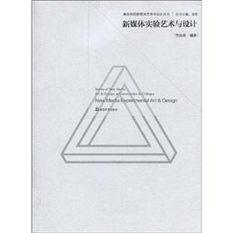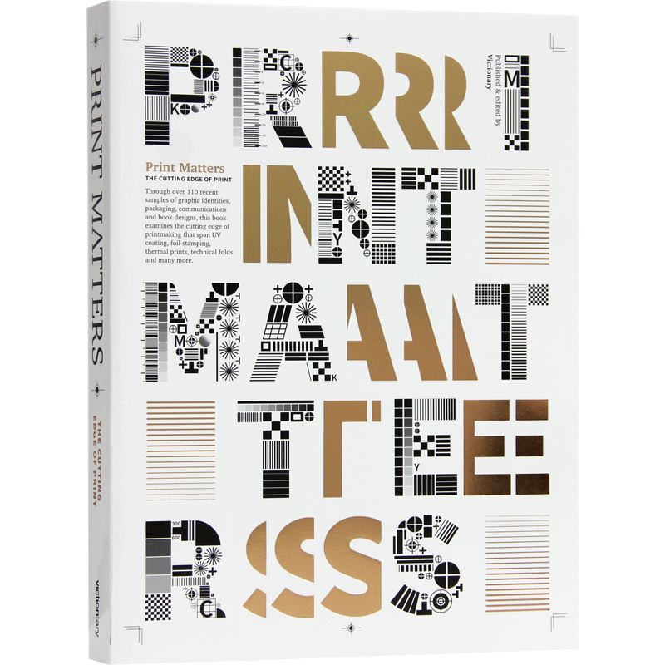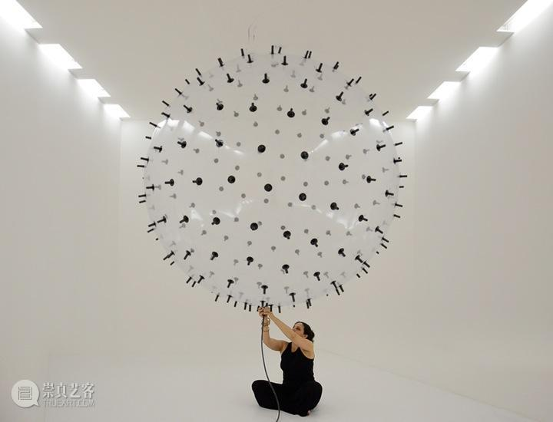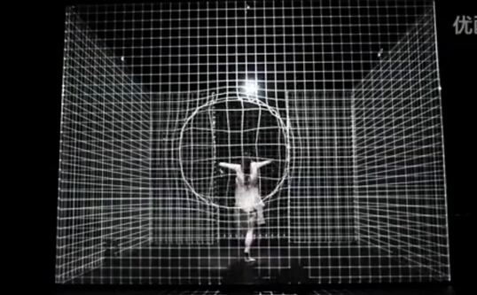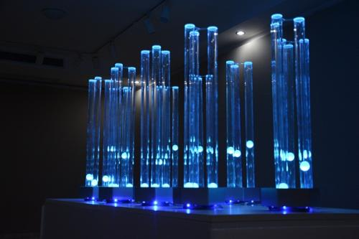

– Draft website text

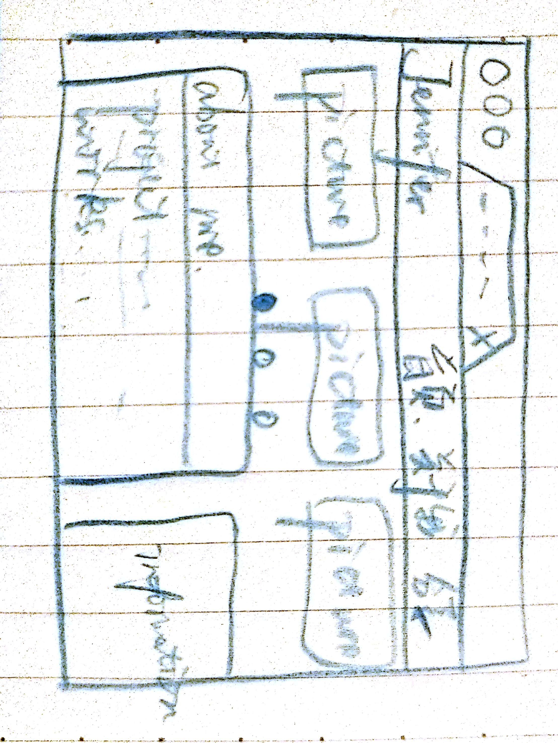

– Make a list of any external links

1.http://www.artlinkart.com/cn/article/overview/62bcuzpm/genres/critique/J

2.https://www.youtube.com/playlist?list=PLyW-UF4UkT6ZjoULbWTS8XiND5LuWcXic

3. http://www.sblunwen.com/art/13029.html

4. http://www.artx.cn/exhibit/shanghai.html

5. http://www.53museum.org/?cat=87